**Mass and Energy Balances Applied to Electricity Generation**

EMTH 171

Case Study 2

Logan Lee, [lpl29@uclive.ac.nz](mailto:lpl29@uclive.ac.nz)

Samuel Thornbury, [swt39@uclive.ac.nz](mailto:swt39@uclive.ac.nz)

17th October 2019

# Introduction/Background

The NZ government was aiming to make NZ electricity generation 97% renewable by 2035. In this case study, it will be modelled to be 100% renewable electricity supply. In order to achieve this, hydroelectricity would be increased a little bit, geothermal increased by 70%, and wind power would be increased significantly. The expected power demand in 2035 for this case study was shown in **Table 1** below.

**Table 1. Renewable electricity generation in 2035 for this case study**

|  |  |
| --- | --- |
| **Source** | **GWh/year** |
| Hydro | 25810 |
| Geothermal | 13360 |
| Wind | 14830 |
| **Total** | **54000** |

Task 1 of the case study involved creating a working simulation, implementing the equations to perform Euler’s method in MATLAB to model 1 year (8760 hours) and plotting two separate graphs of time vs lake levels and spillage. The lake levels couldn’t go lower than their supplied lower limit, and if the lake level went higher than the upper limit then the volume of spilt water was calculated. Task 2 was about simple optimisation, finding the required wind turbine capacity for each island that also met the constraints. Also estimating the cost of the extra generating capacity. Task 3 was about finding out more about the system, four different scenarios. This included lower flow rates, wind flow at 50% over a certain time, the rainfall in the South Island consistently at 90% of normal for a year, and, investigating another scenario independently.

# Model summary

Mass and energy balances were applied to electricity generation. Mass balance was applied to hydroelectric lakes which gave the first equation.

Rate of change of mass = flow rate in of mass - flow rate out of mass + generation rate of mass

Density (*ρ)* was constant and uniform, the equation above could be divided by density and work in volume.

Rate of change of volume = flow rate in of volume – flow rate out of volume

For a tank with vertical walls with a surface area,

So

Hence

# Electricity Power was measured in J s–1 or W. For large systems kW or MW are used.

Electrical energy was power over time. 1 kWh (kilowatt-hour) was the energy of 1 kW of power used for 1 hour.

1kWh = 1000Js−1 × 3600s = 3600000J = 3.6MJ

Annual national energy use was often given in GWh/y. This was the average power over a year.

1 GWh/y = 109 Wh/y = 109 Wh/8760 h = 114115 W = 114 kW

Using 114 kW of power continuously for one year (8760 hours) would use 1 GWh of energy. From the total amount of electrical energy required in NZ in 2035, the average continuous power could be calculated.

54 000 GWh/y = 54000 × 109 Wh/8760 h = 6.16×109 W = 6160 MW

# Balancing Power Demand and Supply

With renewable energy, opportunities are lost for controlling the generation of electricity.

* Geothermal ran continuously.
* Wind power was produced only when the wind blew
* The hydro generation had some degree of control, but lakes couldn’t go below minimum levels and could overflow.

The generated power couldn’t be stored because there were no batteries for it. Therefore, the power supply is equal the power demand ()

Electrical power balances for each island:

Equation(2) 𝑃𝐻𝑉𝐷𝐶 = 𝑃𝑁𝐼,𝑑𝑒𝑚𝑎𝑛𝑑 − 𝑃𝑔𝑒𝑜 − 𝑃𝑁𝐼,𝑤𝑖𝑛𝑑 − 𝑃𝑁𝐼,h𝑦𝑑𝑟𝑜

and

Equation(3) 𝑃𝑆𝐼,h𝑦𝑑𝑟𝑜 = 𝑃𝑆𝐼,𝑑𝑒𝑚𝑎𝑛𝑑 + 𝑃𝐻𝑉𝐷𝐶 − 𝑃𝑆𝐼𝑤𝑖𝑛𝑑

# Geothermal

Geothermal electricity plants are very consistent but need maintenance from time to time. With a load factor of 95%. The calculated installed generating capacity in MW to generate 13,360 GWh of geothermal energy per year was 1605 MW, which would be an average of 1525 MW every hour of the year. All the geothermal supply was in the North Island.

# Wind

The average power from wind turbines compared with their maximum capacity.

Where was the time in hours since the start of the year. The year-long average capacity factor was 0.41.

The initial estimate of the required installed capacity of wind was 4130 MW per hour but this capacity could be spread over both islands and it was seen that it needed to be increased.

# Hydroelectricity All hydro lakes were approximated as a single South Island lake and a single North Island lake, each with a large hydroelectricity generator.

**Figure 1. Diagram of a lake and dam showing flows**

The inlet flow, *Fin*, of each lake comes from the rainfall into each catchment which was expressed in as a sine function of time in hours.

The rate of energy generation (power) in MW from a hydro-electric system was given by

Where 𝐹𝑔𝑒𝑛 was the flow rate of water in , *h* was the lake level, was the generator height in metres, was the density of water which was close to and was the gravitational acceleration (). The factor of 0.9 represented the efficiency of generation and was to convert to or . This equation was used for each of the two lakes.

For the North Island lake, with very little storage, it could be assumed that initially

*Equation(8)* 𝐹𝑁𝐼,𝑔𝑒𝑛 = 𝐹𝑁𝐼,𝑖𝑛

But for the South Island, it was possible to calculate the generating flow from the power required (Equation 3) by rearranging Equation (7).

# Hydro spillage If either lake level exceeded the spillway height (if h > h𝑤), there was an extra flow out over the weir, in m3s–1

*Equation(9)* 𝐹𝑠𝑝𝑖𝑙𝑙 = 𝐾𝐿(h − h𝑤)1.5

where *K* was a constant with a typical value of , was the length of the spillway weir (assumed to be 300 m) and *hw* was the height of the weir.

The amount of spillway flow over each year was a measure of the lost generating opportunity. The total was determined by the differential equations below.

was the total volume spilt over the year.

Material balance for each of the two lakes

# Electricity Demand

The North Island power demand in MW was approximated as:

with the mean, 𝜇 =5000 h, and the standard deviation, 𝜎 =1000 h.

South Island demand was expected to be 1940 MW

*Equation(15)* 𝑃𝑆𝐼,𝑑𝑒𝑚𝑎𝑛𝑑 = 1940

At any point in time, the generation needed to match the demand as expressed in Equations (2) and (3).

The value lost from spilt water each year could be calculated with a price of per megawatt through the equation.

# Solution method

# Euler’s method was used to solve the case study problem.

Euler’s method is a numerical method to solve first-order differential equations with a given initial value. Euler’s method is a good method for approximating nice solutions that don’t change rapidly.

# Results and Discussion

**Task 1:**

To build the initial model in MATLAB the task was to plot the North and South Island lake heights against time of one year (**Figure 2**) and the spillage volume against time of one year (**Figure 3**). This gave an idea of whether the model was functioning as expected as it gave a visual representation of the numbers and thus were easily compared against each other. For example, if the spillage graph increased at the same point the height of the lakes hit the max height the model was correct.

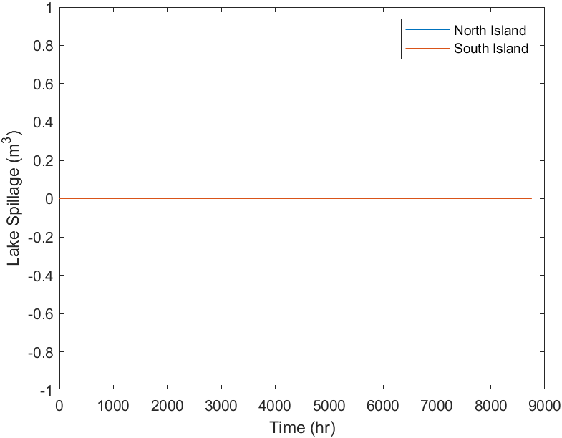

Figure 3: Task 1, Volume of Lake Spillage Against Time

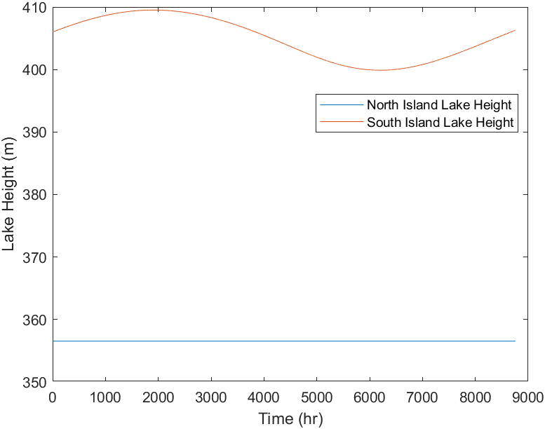

Figure 2: Task 1, Lake Heights Against Time

Additionally, the model was required to print both the minimum lake levels. The model estimated the minimum heights to be for the North Island and for the South Island. The South Island value was below the lower lake height limit of 402 meaning that the dam was ineffectively producing power. It was planned to also calculate the volume of spilt water but as shown in **Figure 3** above, due to the lake height being too low there was no spillage, thus the volume was .

**Task 2:**

As the South Island lake height was below the lower limit it was decided to optimise the wind capacity as the existing value was a guess. To optimise the capacity the output power increased linearly until the minimum South Island lake height did not drop below the lower limit once throughout the year. The optimised wind power output was calculated to be around as a combined value for both islands.

The existing wind power output was and it was estimated to cost for every new kilowatt of wind power added. The required capacity was calculated to a cost of around billion to upgrade New Zealand’s wind power infrastructure to compensate. With the optimised wind power, it was possible to model the South Island lake height against time and the lake spillage against time as shown in **Figure 4** and **Figure 5**.

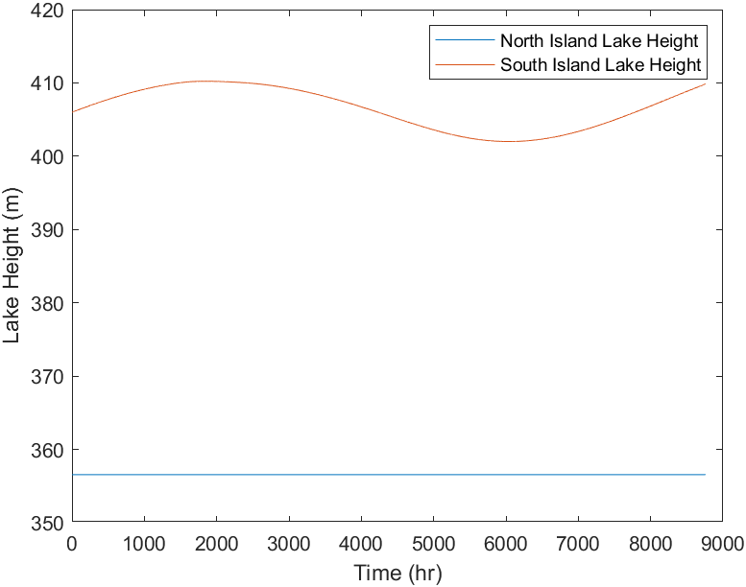

Figure 4: Task 2, Lake Heights Against Time

Figure 5: Task 2, Volume of Lake Spillage Against Time

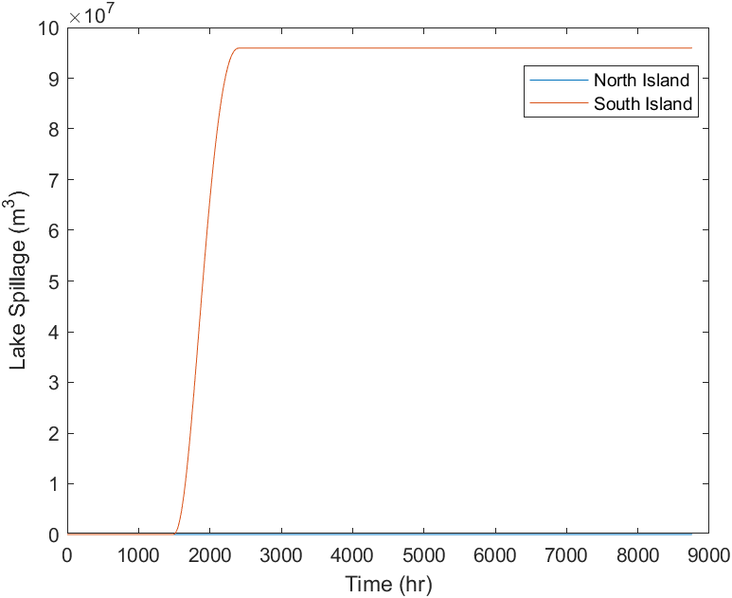

Using equation 16 the value lost due to spilt water was able to be calculated. With a total spillage volume of million a year, the annual money loss was million.

Additionally, the cost of the increased geothermal capacity was calculated. The existing geothermal capacity was and it was estimated to cost per installed kilowatt, therefore with the new capacity of the cost of the upgrade would be around billion. Therefore, a total cost of around billion to meet the power requirements for 2035.

**Task 3:**

Scenario 1:

In this scenario, the model was tested to see the difference if the North Island generating inflow was better optimised. This was done by having lower flow rates in the first the 3 months and the last 3 months of the year while increasing flow during the autumn and winter. The North Island lake had a minimum height of , a hydro lake was required to have at least a height of 355.85m in the North Island. This occurred during the last 9 months of the year, as the inflow was changing from running at 110% to 90%. At that point of inflow change the lake level reached its lowest. With the South Island’s minimum being as shown in **Figure 6**. , just above the South Islands minimum possible hydro lake level.

The volume of spilt water in the South Island (SI) was million . The SI spillage occurred towards the end of the year compared to Figure 4 in task 2 where the spillage was towards the start of the year. The cause of this was that the South Island had to compensate for the North Island during its two-inflow rate decreases in the first and last 3 months of the year. Meaning the South Island had to generate more power to keep up with demand during the North Islands periods of decreased power generation. The lake spillage cost was million. The North Island, however, had no lake spillage.

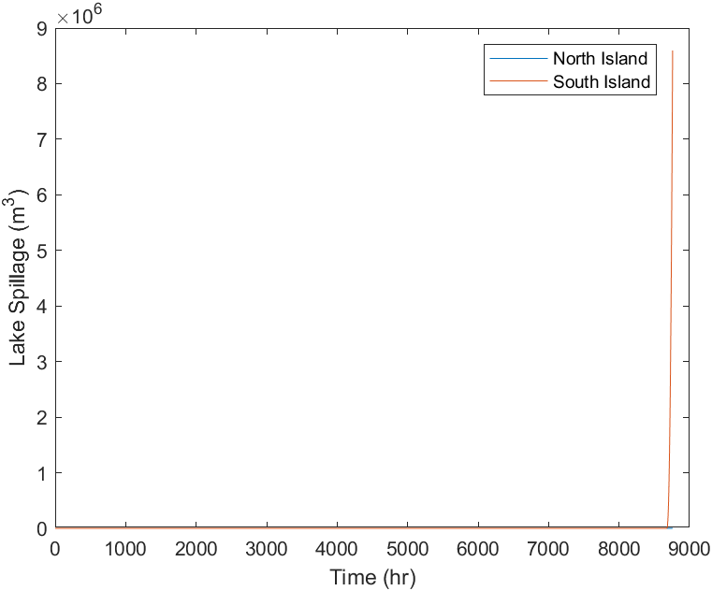

Figure 7: Scenario 1, Volume of Lake Spillage Against Time

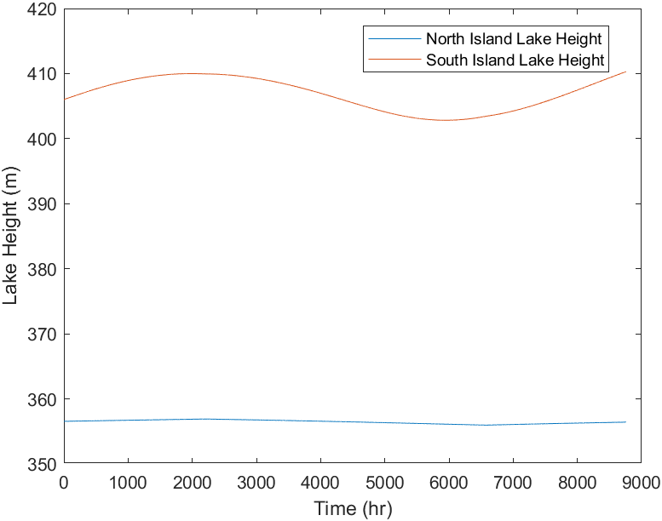

Figure 6: Scenario 1, Lake Heights Against Time

Scenario 2:

In the second scenario, the model was tested to observe what happened when the wind flow in July was 50% of what the normal was. The month of July was in between hours 4344 and 5088. In **Figure 8** it shows that the South Island lake height heavily decreased once the time reached 4344 hours. The minimum lake height was , well below the minimum hydro lake height required. The decrease in the wind flow only affected the South Island hydro lake. Because of the decrease of the wind flow by 50% in July, the South Island hydro lake had to produce the power generation lost from the wind flow decrease. On top of the amount of power, the SI hydro lake was already producing. Hence why there was a sudden decrease in the lake height as more water was being used to meet the power demand. In **Figure 9** the spillage acts similarly to task 2 as the change in wind power in July occurred after the lake spillage, meaning it had no effect on the time in which the lake spillage occurred.

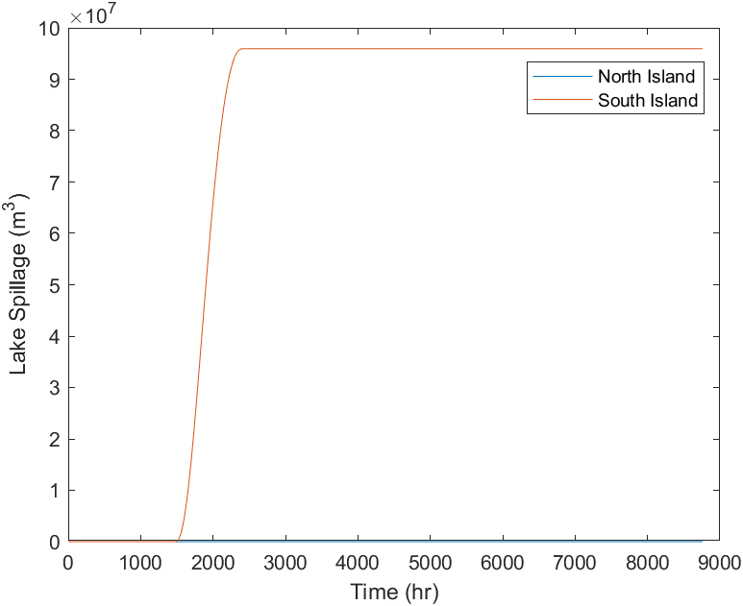

Figure 9: Scenario 2, Volume of Lake Spillage Against Time

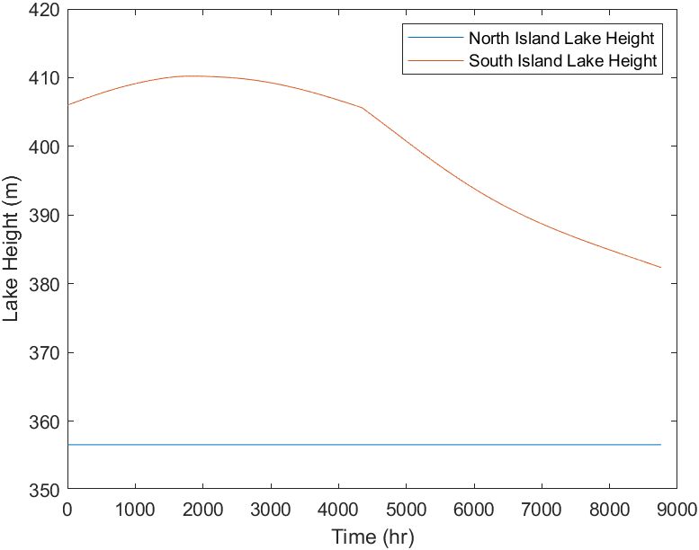

Figure 8: Scenario 2, Lake Heights Against Time

Scenario 3:

In this scenario, the system was tested to see what happened when the rainfall in the South Island was always 90% of the normal for a year. As expected, this caused the height of the South Island lake to have an overall decrease when compared to past scenarios as shown in **Figure 10**. The lack of rainfall has caused the height of the lake to stay below the upper limit, therefore, there was no spillage as shown in **Figure 11**. The minimum lake height for the South Island was . This was below the minimum lake height of required to have an adequate hydro lake. The lowest point occurred around the 9th month of the year. To improve this model and stop the lake from falling below the minimum height required, an idea would be to have the rainfall at 100% (normal rainfall) during months 7, 8, and, 9 of the year. This would enable the lake height to potentially not drop below the minimum lake height for the SI hydro lake of 402m while also remaining below the maximum height for a SI hydro lake.

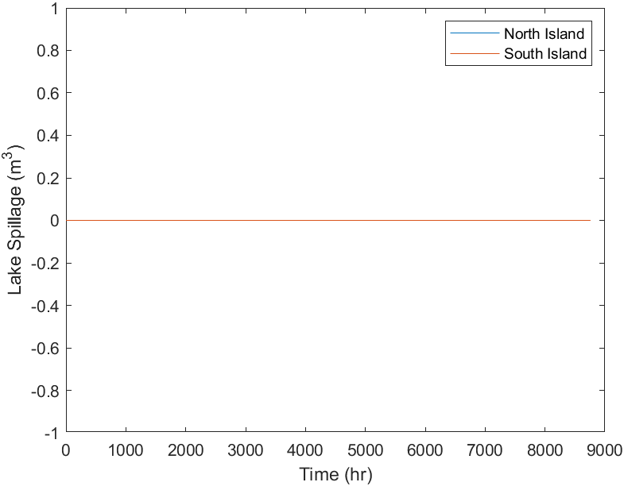

Figure 11: Scenario 3, Volume of Lake Spillage Against Time

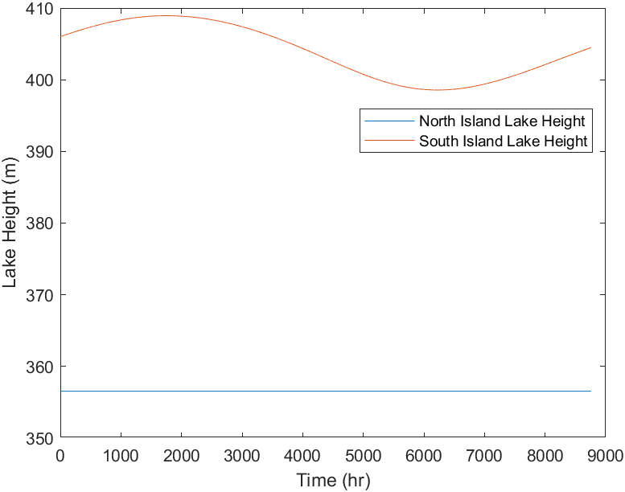

Figure 10: Scenario 3, Lake Heights Against Time

Scenario 4:

In the final scenario, the model explores the global crisis of overpopulation. As there was an increase in people moving to New Zealand, which could be due to the overpopulation of the globe. In the year 2035, if New Zealand ran out of area for usable ground it could be possible that the lakes would be required to be partially filled to provide more ground for housing or other reasons. Partially filling in the lakes would cause the area of the lakes to decrease by a potential 20%.

The area decrease has a major impact on the amount of water spilt in the year as shown in **Figure 12** and **Figure 13** as the lakes have the same inlet flow of water but there was less of a reservoir for the water be stored in. Causing the lake spillage to occur earlier on in the year, compared to when the lake hadn’t had a decrease in area.

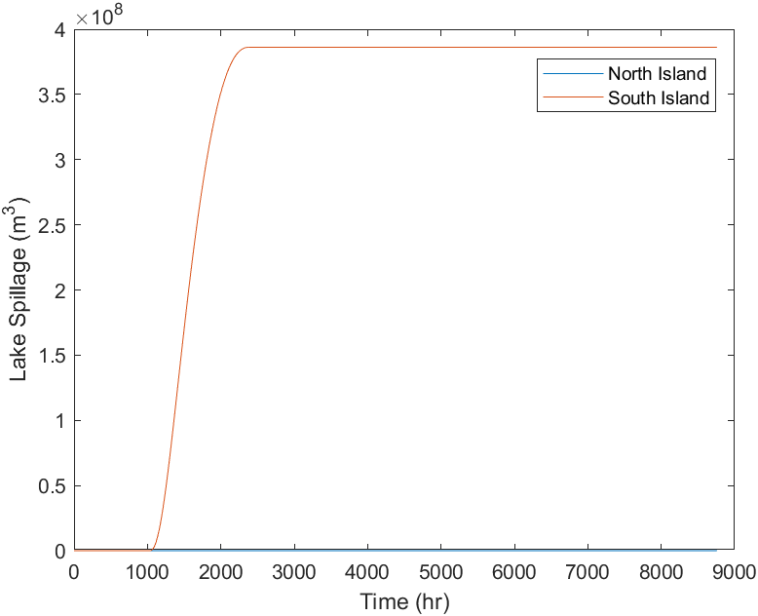

Figure 13: Scenario 4, Volume of Lake Spillage Against Time

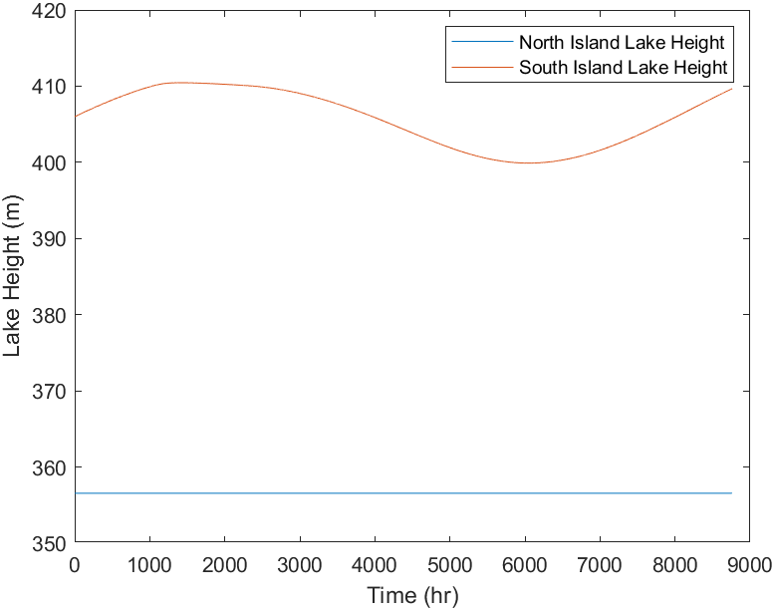

Figure 12: Scenario 4, Lake Heights Against Time

In **Figure 11** there was a large chunk of the year between 1081 and 2392 hours where the lake in just spilling which leads to a loss of around $34.37 million worth of energy each year. Additionally, the height of the South Island lake drops below the lower height limit. To resolve these two problems both the height of the dam would have to be increased and other power sources would have to better optimised to allow for the hydroelectric dams to work more efficiently and effectively. Another way to stop the spillage from occurring could be to add another turbine into the dam, this would enable the hydro lake to increase the out flow of water by a considerable amount. A bonus to this would be the hydro lakes ability to generate more power, and money from having no spillage of water.

# Appendix

% EMTH 171, Case Study 2

% Task 1

% Mass and Energy Balances Applied to Electricity Generation

% Euler’s Method

% Logan Lee

clear

clc

close all

% *************************************************************************

% Variables

% *************************************************************************

%------------------------ Global Variables --------------------------------

p = 998; % Density (kg/m^3)

g = 9.81; % Gravity (m/s^2)

K = 1.55; % A constant (m^1.5/s)

L = 300; % Length of spillway weir (m)

mean = 5000; % Mean of normal distribution

sd = 1000; % Standard Deviation

P_geo = 1525; % Geothermal Power (MW)

P_w = 4130; % Wind Power (MW)

% Pre allocating Arrays

h_NIArray = zeros(0,8761);

h_SIArray = zeros(0,8761);

dV_NIspillArray = zeros(0,8761);

dV_SIspillArray = zeros(0,8761);

dh_NIArray = zeros(0,8761);

dh_SIArray = zeros(0,8761);

%------------------ North Island Specific Variables -----------------------

A_NI = 620e6; % Area of lake North Island (m^2)

h_NIArray(1) = 356.55; % Height of North Island Lake (m)

h_NIgen = 80; % Generator height North Island (m)

P_NIw = P_w/2; % Wind Power in the North Island (MW)

h_NIw = 357.25; % North Island Weir height (m)

%------------------ South Island Specific Variables -----------------------

A_SI = 350e6; % South Island Lake Area (m^2)

P_SIw = P_w/2; % South Island Wind Power (MW)

h_SIArray(1) = 406; % Height of South Island Lake (m)

h_SIgen = 0; % Height of Generator South Island (m)

h_SIw = 410; % South Island weir height (m)

% *************************************************************************

% Euler's Method

% *************************************************************************

t0 = 0; % Initial time (s)

tf = 8760; % Final time (s)

tArray = t0 : tf; % Time array from initial to final Time

h = 1 * 3600; % Step size, 3600 for unit balancing

% Initialising the arrays for each equation with their initial values

dV_NIspillArray(1) = 0;

dV_SIspillArray(1) = 0;

dh_NIArray(1) = 356.55;

dh_SIArray(1) = 406;

for n = 2 : length(tArray)

t = tArray(n-1);

% North and South Island power demands

P_NIdem = 4065 + 1.4e6*normpdf(t, mean, sd);

P_SIdem = 1940;

% North and South Island inlet flow Rate

F_NIin = 345 + 73*sin((2*pi*(t-3624))/8760);

F_SIin = 593 - 183*sin((2*pi*(t-2320))/8760);

% North Island Flow generation

F_NIgen = F_NIin;

% Power Generated by hydro

P_NIhydro = (0.9*F_NIgen*p*g*(h_NIArray(n-1) - h_NIgen))/1e6;

% Capacity Factor of wind turbines

CF = 0.41 + 0.12*sin((2*pi*(t - 5660))/8760);

% Total Power produced on North Island

P_NItot = P_NIhydro + P_geo + P_NIw*CF;

% Electrical power balance for the Islands

P_HVDC = P_NIdem - P_NItot;

% The amount of hydro power required for South Island

P_SIhydro = P_SIdem + P_HVDC - P_SIw*CF;

% Generating flow rate for South Island

F_SIgen = ((P_SIhydro*1e6)/(0.9*p*g*(h_SIArray(n-1))));

% Spillway flow for each lake

%North Island

if h_NIArray(n-1) > h_NIw

F_NIspill = K*L*(h_NIArray(n-1) - h_NIw)^1.5;

else

F_NIspill = 0;

end

%South Island

if h_SIArray(n-1) > h_SIw

F_SIspill = K*L*(h_SIArray(n-1) - h_SIw)^1.5;

else

F_SIspill = 0;

end

% The differential Equations

dV_NIspill = F_NIspill; % Spill Volume of the North Island (m^3)

dV_SIspill = F_SIspill; % Spill Volume of the South Island (m^3)

dh_NI = (F_NIin - F_NIgen - F_NIspill)/A_NI; % Lake Height of NI (mm)

dh_SI = (F_SIin - F_SIgen - F_SIspill)/A_SI; % Lake Height of SI mm)

h_NIArray(n) = h_NIArray(n-1) + dh_NI*3600;

h_SIArray(n) = h_SIArray(n-1) + dh_SI*3600;

dV_NIspillArray(n) = dV_NIspillArray(n-1) + h*dV_NIspill;

dV_SIspillArray(n) = dV_SIspillArray(n-1) + h*dV_SIspill;

dh_NIArray(n) = dh_NIArray(n-1) + h*dh_NI;

dh_SIArray(n) = dh_SIArray(n-1) + h*dh_SI;

end

% *************************************************************************

% Plotting and printing the data

% *************************************************************************

% Lake heights plot

figure(1)

plot(tArray, dh_NIArray, tArray, dh_SIArray)

legend("North Island Lake Height", "South Island Lake Height")

xlabel("Time (hr)")

ylabel("Lake Height (m)")

% Lake spillage plot

figure(2)

plot(tArray, dV_NIspillArray, tArray, dV_SIspillArray);

legend("North Island", "South Island")

xlabel("Time (hr)")

ylabel("Lake Spillage (m^3)")

h_NImin = min(h_NIArray) % Minimum height of the North Island lake

h_SImin = min(h_SIArray) % Minimum height of the South Island lake

V_NIspilled = max(dV_NIspillArray) % Volume spilled from North Island

V_SIspilled = max(dV_SIspillArray) % Volume spilled from South Island

Task 2:

% EMTH 171, Case Study 2

% Task 2

% Mass and Energy Balances Applied to Electricity Generation

% Euler’s Method

% Logan Lee

clear

clc

close all

% *************************************************************************

% Variables

% *************************************************************************

%------------------------ Global Variables --------------------------------

p = 998; % Density (kg/m^3)

g = 9.81; % Gravity (m/s^2)

K = 1.55; % A constant (m^1.5/s)

L = 300; % Length of spillway weir (m)

mean = 5000; % Mean of normal distribution

sd = 1000; % Standard Deviation

P_geo = 1525; % Geothermal Power (MW)

P_w = 4130; % Wind Power (MW)

%------------------ North Island Specific Variables -----------------------

A_NI = 620e6; % Area of lake North Island (m^2)

h_NIgen = 80; % Generator height North Island (m)

P_NIw = P_w/2; % Wind Power in the North Island (MW)

h_NIw = 357.25; % North Island Weir height (m)

%------------------ South Island Specific Variables -----------------------

A_SI = 350e6; % South Island Lake Area (m^2)

P_SIw = P_w/2; % South Island Wind Power (MW)

h_SIgen = 0; % Height of Generator South Island (m)

h_SIw = 410; % South Island weir height (m)

% *************************************************************************

% Euler's Method

% *************************************************************************

t0 = 0; % Initial time (s)

tf = 8760; % Final time (s)

tArray = t0 : tf; % Time array from initial to final Time

h = 1 * 3600; % Step size, 3600 for unit balancing

%Intialising the h_SI min for while loop

h_SIArrayMin = 399.88;

h_SImin = 402;

while h_SIArrayMin < h_SImin

P_w = P_w + 1;

P_NIw = P_w/2; % Wind Power in the North Island (MW)

P_SIw = P_w/2; % South Island Wind Power (MW)

% Pre allocating Arrays

h_NIArray = zeros(0,8761);

h_SIArray = zeros(0,8761);

dV_NIspillArray = zeros(0,8761);

dV_SIspillArray = zeros(0,8761);

dh_NIArray = zeros(0,8761);

dh_SIArray = zeros(0,8761);

% Initialising the arrays for each equation with their initial values

h_NIArray(1) = 356.55; % Height of North Island Lake (m)

h_SIArray(1) = 406; % Height of South Island Lake (m)

dV_NIspillArray(1) = 0;

dV_SIspillArray(1) = 0;

dh_NIArray(1) = 356.55;

dh_SIArray(1) = 406;

for n = 2 : length(tArray)

t = tArray(n-1);

% North and South Island power demands

P_NIdem = 4065 + 1.4e6*normpdf(t, mean, sd);

P_SIdem = 1940;

% North and South Island inlet flow Rate

F_NIin = 345 + 73*sin((2*pi*(t-3624))/8760);

F_SIin = 593 - 183*sin((2*pi*(t-2320))/8760);

% North Island Flow generation

F_NIgen = F_NIin;

% Power Generated by hydro

P_NIhydro = (0.9*F_NIgen*p*g*(h_NIArray(n-1) - h_NIgen))/1e6;

% Capacity Factor of wind turbines

CF = 0.41 + 0.12*sin((2*pi*(t - 5660))/8760);

% Total Power produced on North Island

P_NItot = P_NIhydro + P_geo + P_NIw*CF;

% Electrical power balance for the Islands

P_HVDC = P_NIdem - P_NItot;

% The amount of hydro power required for South Island

P_SIhydro = P_SIdem + P_HVDC - P_SIw*CF;

% Generating flow rate for South Island

F_SIgen = ((P_SIhydro*1e6)/(0.9*p*g*(h_SIArray(n-1))));

% Spillway flow for each lake

%North Island

if h_NIArray(n-1) > h_NIw

F_NIspill = K*L*(h_NIArray(n-1) - h_NIw)^1.5;

else

F_NIspill = 0;

end

%South Island

if h_SIArray(n-1) > h_SIw

F_SIspill = K*L*(h_SIArray(n-1) - h_SIw)^1.5;

else

F_SIspill = 0;

end

% The differential Equations

dV_NIspill = F_NIspill; % Spill Volume of the North Island (m^3)

dV_SIspill = F_SIspill; % Spill Volume of the South Island (m^3)

dh_NI = (F_NIin - F_NIgen - F_NIspill)/A_NI; % Lake Height of NI (mm)

dh_SI = (F_SIin - F_SIgen - F_SIspill)/A_SI; % Lake Height of SI (mm)

h_NIArray(n) = h_NIArray(n-1) + dh_NI*3600;

h_SIArray(n) = h_SIArray(n-1) + dh_SI*3600;

dV_NIspillArray(n) = dV_NIspillArray(n-1) + h*dV_NIspill;

dV_SIspillArray(n) = dV_SIspillArray(n-1) + h*dV_SIspill;

dh_NIArray(n) = dh_NIArray(n-1) + h*dh_NI;

dh_SIArray(n) = dh_SIArray(n-1) + h*dh_SI;

end

h_SIArrayMin = min(h_SIArray); % Minimum height of the SI lake

end

% *************************************************************************

% Printing the data

% *************************************************************************

% Lost money from spillage with optimised wind power

windSpillValue = ((0.9*p*(max(dV_SIspillArray))*g*(max(h_SIArray)))/ ...

(3600*10^6))*10;

% Assigning the optimised wind power to a variable

windPower = P_w

% Cost of both new wind and geothermal power

windCost = (windPower - 580)*1000*3000

geoCost = (1605 - 960)*1000*4500

Task 3, Scenario 1:

% EMTH 171, Case Study 2

% Task 3, Scenario 4 (Own investigation)

% Mass and Energy Balances Applied to Electricity Generation

% Euler’s Method

% Logan Lee

clear

clc

close all

% *************************************************************************

% Variables

% *************************************************************************

%------------------------ Global Variables --------------------------------

p = 998; % Density (kg/m^3)

g = 9.81; % Gravity (m/s^2)

K = 1.55; % A constant (m^1.5/s)

L = 300; % Length of spillway weir (m)

mean = 5000; % Mean of normal distribution

sd = 1000; % Standard Deviation

P_geo = 1525; % Geothermal Power (MW)

P_w = 4484; % Wind Power (MW)

% Pre allocating Arrays

h_NIArray = zeros(0,8761);

h_SIArray = zeros(0,8761);

dV_NIspillArray = zeros(0,8761);

dV_SIspillArray = zeros(0,8761);

dh_NIArray = zeros(0,8761);

dh_SIArray = zeros(0,8761);

%------------------ North Island Specific Variables -----------------------

A_NI = (620e6)*0.8; % Area of lake North Island (m^2)

h_NIArray(1) = 356.55; % Height of North Island Lake (m)

h_NIgen = 80; % Generator height North Island (m)

P_NIw = P_w/2; % Wind Power in the North Island (MW)

h_NIw = 357.25; % North Island Weir height (m)

%------------------ South Island Specific Variables -----------------------

A_SI = (350e6)*0.8; % South Island Lake Area (m^2)

P_SIw = P_w/2; % South Island Wind Power (MW)

h_SIArray(1) = 406; % Height of South Island Lake (m)

h_SIgen = 0; % Height of Generator South Island (m)

h_SIw = 410; % South Island weir height (m)

% *************************************************************************

% Euler's Method

% *************************************************************************

t0 = 0; % Initial time (s)

tf = 8760; % Final time (s)

tArray = t0 : tf; % Time array from initial to final Time

h = 1 * 3600; % Step size, 3600 for unit balancing

% Initialising the arrays for each equation with their initial values

dV_NIspillArray(1) = 0;

dV_SIspillArray(1) = 0;

dh_NIArray(1) = 356.55;

dh_SIArray(1) = 406;

for n = 2 : length(tArray)

t = tArray(n-1);

% North and South Island power demands

P_NIdem = 4065 + 1.4e6*normpdf(t, mean, sd);

P_SIdem = 1940;

% North and South Island inlet flow Rate

F_NIin = 345 + 73*sin((2*pi*(t-3624))/8760);

F_SIin = 593 - 183*sin((2*pi*(t-2320))/8760);

% North Island Flow generation

F_NIgen = F_NIin;

% Power Generated by hydro

P_NIhydro = (0.9*F_NIgen*p*g*(h_NIArray(n-1) - h_NIgen))/1e6;

% Capacity Factor of wind turbines

CF = 0.41 + 0.12*sin((2*pi*(t - 5660))/8760);

% Total Power produced on North Island

P_NItot = P_NIhydro + P_geo + P_NIw*CF;

% Electrical power balance for the Islands

P_HVDC = P_NIdem - P_NItot;

% The amount of hydro power required for South Island

P_SIhydro = P_SIdem + P_HVDC - P_SIw*CF;

% Generating flow rate for South Island

F_SIgen = ((P_SIhydro*1e6)/(0.9*p*g*(h_SIArray(n-1))));

% Spillway flow for each lake

%North Island

if h_NIArray(n-1) > h_NIw

F_NIspill = K*L*(h_NIArray(n-1) - h_NIw)^1.5;

else

F_NIspill = 0;

end

%South Island

if h_SIArray(n-1) > h_SIw

F_SIspill = K*L*(h_SIArray(n-1) - h_SIw)^1.5;

else

F_SIspill = 0;

end

% The differential Equations

dV_NIspill = F_NIspill; % Spill Volume of the North Island (m^3)

dV_SIspill = F_SIspill; % Spill Volume of the South Island (m^3)

dh_NI = (F_NIin - F_NIgen - F_NIspill)/A_NI; % Lake Height of NI (mm)

dh_SI = (F_SIin - F_SIgen - F_SIspill)/A_SI; % Lake Height of SI (mm)

h_NIArray(n) = h_NIArray(n-1) + dh_NI*3600;

h_SIArray(n) = h_SIArray(n-1) + dh_SI*3600;

dV_NIspillArray(n) = dV_NIspillArray(n-1) + h*dV_NIspill;

dV_SIspillArray(n) = dV_SIspillArray(n-1) + h*dV_SIspill;

dh_NIArray(n) = dh_NIArray(n-1) + h*dh_NI;

dh_SIArray(n) = dh_SIArray(n-1) + h*dh_SI;

end

% Lost money from spillage with optimised wind power

spillValue = ((0.9*p*(max(dV_SIspillArray))*g*(max(h_SIArray)))/ ...

(3600*10^6))*100;

% *************************************************************************

% Plotting and printing the data

% *************************************************************************

% Lake heights plot

figure(1)

plot(tArray, dh_NIArray, tArray, dh_SIArray)

legend("North Island Lake Height", "South Island Lake Height")

xlabel("Time (hr)")

ylabel("Lake Height (m)")

% Lake spillage plot

figure(2)

plot(tArray, dV_NIspillArray, tArray, dV_SIspillArray);

legend("North Island", "South Island")

xlabel("Time (hr)")

ylabel("Lake Spillage (m^3)")

h_NImin = min(h_NIArray) % Minimum height of the North Island lake

h_SImin = min(h_SIArray) % Minimum height of the South Island lake

V_NIspilled = max(dV_NIspillArray) % Volume spilled from North Island

V_SIspilled = max(dV_SIspillArray) % Volume spilled from South Island

As Task 3 was just changing variables, previous scenarios are slightly different to this code